Dr. Sachchidanand Sinha
Micro theory of consumption
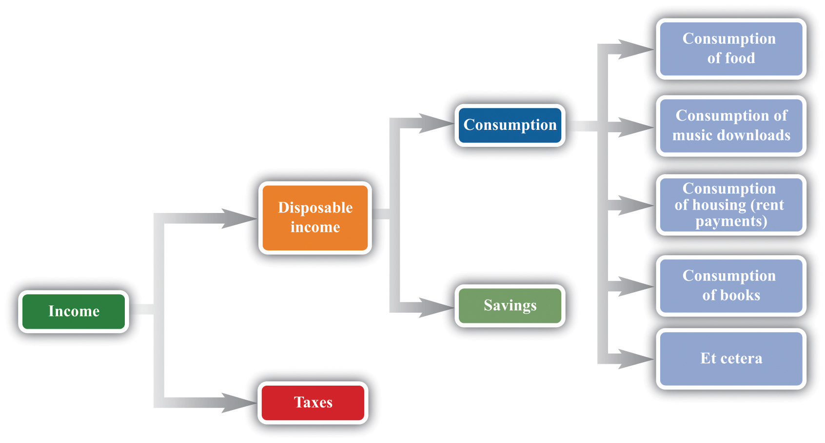

What Is Consumer Theory?
Consumer theory is the study of how people decide to spend their money based on their individual preferences and budget constraints. A branch of microeconomics, consumer theory shows how individuals make choices, subject to how much income they have available to spend and the prices of goods and services.
Understanding how consumers operate makes it easier for vendors to predict which of their products will sell more and enables economists to get a better grasp of the shape of the overall economy.
- Consumer theory is the study of how people decide to spend their money based on their individual preferences and budget constraints.
- Building a better understanding of individuals' tastes and incomes is important because these factors impact the shape of the overall economy.
- Consumer theory is not flawless, though, as it based on a number of assumptions about human behavior.

Understanding:-

Individuals have the freedom to choose between different bundles of goods and services. Consumer theory seeks to predict their purchasing patterns by making the following three basic assumptions about human behavior:
- Utility maximization: Individuals are said to make calculated decisions when shopping, purchasing products that bring them the greatest benefit, otherwise known as maximum utility in economic terms
- Nonsatiation: People are seldom satisfied with one trip to the shops and always want to consume more
- Decreasing marginal utility: Consumers lose satisfaction in a product the more they consume it
Working through examples and/or cases, consumer theory usually requires the following inputs:
- A full set of consumption options
- How much utility a consumer derives from each bundle in the set of options
- A set of prices assigned to each bundle
- Any initial bundle the consumer currently holds

Advantages of Consumer Theory:-
Building a better understanding of individuals' tastes and incomes is important because it has a big bearing on the demand curve, the relationship between the price of a good or service and the quantity demanded for a given period of time, and the shape of the overall economy.
Consumer spending drives a significantly large chunk of gross domestic product (GDP) in the U.S. and other nations. If people cut down on purchases, demand for goods and services will fall, squeezing company profits, the labor market, investment, and many other things that make the economy tick.

Consumer choice theory is taken very seriously, influencing everything from government policy to corporate advertising.

Example of Consumer Theory :-

Let’s look at an example. Kyle is a consumer with a budget of $200, who must choose how to allocate his funds between pizza and video games (the bundle of goods). If a pizza costs $10 and a video game cost $50, Kyle could buy 20 pizzas, or four video games, or five pizzas and three video games. Alternatively, he could keep all $200 in his pocket.
How can an outsider predict how Kyle is most likely to spend his money? Consumer theory can help give an answer to this question.

Limitations of Consumer Theory:-

Challenges to developing a practical formula for this situation are numerous. For instance, as behavioral economics points out, people are not always rational and are occasionally indifferent to the choices available. Some decisions are particularly difficult to make because consumers are not familiar with the products. There could also be an emotional component involved in the decision-making process that isn't able to be captured in an economic function.
The many assumptions that consumer theory makes means it has come under heavy criticism. While its observations may be valid in a perfect world, in reality there are numerous variables that can expose the process of simplifying spending habits as flawed.
Going back to the example of Kyle, figuring out how he will spend his $200 is not as clear-cut as it might at first seem. Economics assumes he understands his preferences for pizza and video games and can decide how much of each he wants to purchase. It also presumes there are enough video games and pizzas available for Kyle to choose the quantity of each he desires.
Consumer Theory: Preferences:-
List of specific quantities of distinct goods and services
Example: Two goods x and y. (x,y) = (quantity good x, quantity good y)
e.g. (x,y)=(coffee, shoes)
Consumer has to be able to rank all the bundles in order to identify which one he likes the most.
We simplify the problem by assuming that there are only two goods, x and y (e.g., food and clothes).
BUNDLE | UNIT OF FOOD (x) | UNIT OF CLOTHES(y)
B | 10 | 50
C | 20 | 30
D | 40 | 20
E | 30 | 40
F | 10 | 20
We will assume that goods a perfectly divisible so that every point in the positive part of the real plane is a possible bundle.
Let A=(x,y) and B=(xʼ,yʼ) be two bundles.
≿ : preference relation; A ≿ B (A is preferred or indifferent to B).
≻ : strict preference relation;
A ≻ B (A is preferred to B) -- A ≿ B, but not B ≿ A. ~:

indifference relation; A ~ B (A is indifferent to B) -- A ≿ B and B ≿ A.
Examples:
Let A = (x,y) and B = (xʼ,yʼ) be two bundles.
1. Pareto: A ≿ B if x ≥ xʼ and y ≥ yʼ.
2. Lexicographic: A ≿ B if x > xʼ or [x = xʼ and y ≥ yʼ].
3. Goods and “Bads” (pollution, waste): A ≿ B if x - y ≥ xʼ- yʼ.
4. Perfect substitutes: A ≿ B if x + y ≥ xʼ+yʼ.
5. Imperfect substitutes: A ≿ B if xy ≥ xʼyʼ.
6. Complements: A ≿ B if min{x,y} ≥ min{xʼ,yʼ}.

